**PIZZA SALES SQL QURIES**

**1. Total Revenue**

SELECT SUM(total_price) AS Total_Revenue

FROM pizza_sales

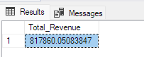

**2. Average Order Value**

SELECT SUM(total_price)/COUNT(DISTINCT(order_id)) as average_order_value

FROM pizza_sales

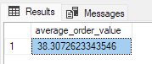

**3 Total Pizza Sold**

SELECT SUM(quantity) AS Total_Pizza_Sold

FROM pizza_sales

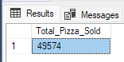

**4 Total Orders**

SELECT COUNT(DISTINCT order_id) AS Total_Orders

FROM pizza_sales

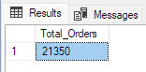

**5 Average Quantity per Order**

SELECT CAST(CAST(SUM(quantity) AS decimal(10,2)) / CAST(COUNT(DISTINCT order_id) AS decimal(10,2)) AS DECIMAL (10,2)) AS Average_Quantity_per_Order

FROM pizza_sales

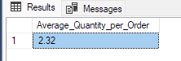

**DAILY AND MONTHLY TRENDS**

**1 Daily Orders**

SELECT DATENAME(DW, order_date) AS Order_Day, COUNT(DISTINCT order_id) AS Total_Orders

FROM pizza_sales

GROUP BY DATENAME(DW, order_date)

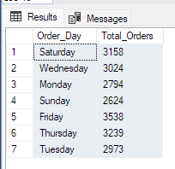

**2 Monthly Orders**

SELECT DATENAME(month, order_date) AS Month, COUNT(DISTINCT order_id) AS Total_Orders

FROM pizza_sales

GROUP BY DATENAME(month, order_date), MONTH(order_date)

ORDER BY MONTH(order_date)

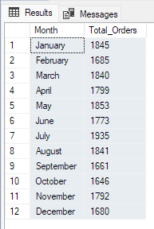

**3 Percentage of Sales by Pizza Category**

SELECT DISTINCT pizza_category as Pizza_Category, CAST((SUM(total_price) * 100/ (SELECT SUM(total_price) from pizza_sales)) AS DECIMAL(10,2)) AS PCT

FROM pizza_sales

GROUP BY pizza_category

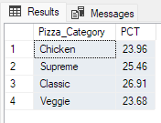

**4 Percentage of Sales by Pizza Size**

SELECT pizza_size as Pizza_Size, CAST(SUM(total_price) * 100 / (SELECT SUM(total_price) FROM pizza_sales) AS DECIMAL(10,2)) AS PCT

FROM pizza_sales

GROUP BY pizza_size

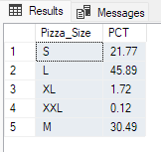

**5 Total Pizzas Sold by Pizza Category**

SELECT pizza_category, SUM(quantity) AS Toal_Quantity_per_category

FROM pizza_sales

GROUP BY pizza_category

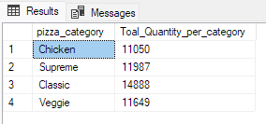

**6 Top 5 Pizza by Revenue**

SELECT TOP 5 pizza_name, SUM(total_price) AS Total_Revenue

FROM pizza_sales

GROUP BY pizza_name

ORDER BY Total_Revenue DESC

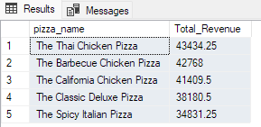

**7 Bottom 5 Pizza by Revenue**

SELECT TOP 5 pizza_name, SUM(total_price) AS Total_Revenue

FROM pizza_sales

GROUP BY pizza_name

ORDER BY Total_Revenue ASC

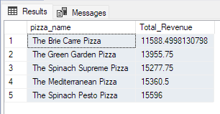

**8 Top 5 Pizza by Quantity Sold**

SELECT TOP 5 pizza_name, SUM(quantity) AS Total_Quantity_Sold

FROM pizza_sales

GROUP BY pizza_name

ORDER BY Total_Quantity_Sold DESC

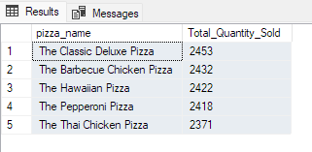

**9 Bottom 5 Pizza by Quantity Sold**

SELECT TOP 5 pizza_name, SUM(quantity) AS Total_Quantity_Sold

FROM pizza_sales

GROUP BY pizza_name

ORDER BY Total_Quantity_Sold ASC

